Quarters 1-4 , 2014-2018 Big Ideas:
Environmental Science AP Instructor: Gillian Moberg

- CASE STUDIES: (most show the result of overdraft or diversion of water; economic, social and environmental importance of water but also the tragedy of the commons and how human activities can impact water)

A. California Water Challenge: about 66% of the precipitation falls in Northern
CA. and about 66% of the population lives in Southern CA.

B. Colorado River: headwater = in Colorado, dams (Hoover, Glen Canyon,
Parker, Davis, others), reservoirs (Lake Mead, Lake Powell); environmental impact- reduced fertility on farmlands below the dam since river does not flood the plains blockage of fish spawning; high salinity of soils below dam; economic impact- loss of profit from competition between agriculture and domestic water users; legal water right disputes between states, individual users and Mexico; loss of revenue from recreational use such as wildlife tours and fishing licenses and commercial fishing; increased revenue from hydroelectricity

C. Mono Lake: Eastern Sierra, CA: consequence of water diversion to Los Angeles via aqueduct includes increased water salinity and reduced quantity of drinking water for LA.

D. Aral Sea: once the world’s fourth freshwater lake; is located in an area of the former Soviet Union (Kazakhstan, Uzbekistan, Turkmenistan); the shrinking of the Aral Sea is due to large-scale water transfers for agriculture (irrigation) starting in 1960; two rivers (the Syr Darya and the Amu Darya were largely diverted in order to grow water thirsty cotton and food crops; lake surface area has shrunk by about 40%, its volume has decreased by over 50%, former lake bottom has become a human-made desert covered with salty residue; the sea’s salinity has tripled; twenty of twenty-four native fish species have become extinct; regional air pollution(SPM); Climate has changed due to diminished moderating effect of larger body of water in the pre-1960 Aral Sea – colder winters & warmer summers; increased respiratory and kidney diseases from dust storms and salty water

E. Florida Everglades-the largest freshwater wetland in North America: Channelization of Kissimmee River interrupted the ecosystem services of Everglades wetlands. To channelize is to straighten and line with concrete
THE ecological, economic and social services of WETLANDS-
- Wetlands remove between 70-90% of nitrogen entering by runoff and floodwater
- Wetlands with high soil concentrations of aluminum can remove up to 80% of phosphorus from runoff
- Wetlands can remove BOD introduced to the surface water through sewage effluent, surface runoff and natural biotic processes by 100%.
- Suspended solids in stormwater runoff are trapped by the roots of the plants in a wetland. This reduces turbidity in downstream ecosystems. Wetland vegetation can trap 80-90% of sediments from runoff
- Certain wetlands can remove metals in the water. Eelgrass can bioaccumulate lead, removing it from the water. Metals can also be bound to wetland soils, effectively removing metals downstream of urbanized areas
- Pathogens such as fecal coliform enter wetlands through municipal sewage, urban stormwater, leaking septic tanks and agricultural runoff. Bacteria attach to suspended solids and are trapped by the wetland vegetation.
- Wetlands act as reservoirs for the watershed, recharging surface and groundwater systems
- Flood protection downstream increases with wetlands. Stormwater runoff is slowed when the water enters the wetland
- Erosion protection since wetland plants hold the soil in place with their roots, absorb wave energy and slows the currents from rivers. Coastal wetlands buffer shorelines against the wave action produced by hurricanes or tropical storms
- Wetlands are a habitat for diverse species of plants, insects, amphibians, reptiles, birds, fish and mammals. Most commercial and game fish breed and young develop in coastal marshes and estuaries (an economic incentive). Shrimp, oyster, clams, crabs, salmon, sea trout and sea bass are some of the species that depend on wetlands for food and habitat Migratory water birds rely on wetlands for resting, feeding, breeding or nesting grounds
- Observing and photographing wildlife, hunting and fishing all generate billions of dollars for the economy
- Natural carbon scrubbers by capturing carbon dioxide into wetland plants that then get buried and converted to peat, reducing the greenhouse effect
- Economically important products harvested from wetlands include cranberries, timber (wood), wild rice and some medicines (of course fish and shellfish)

F. Chesapeake Bay, Maryland/Virginia: the largest estuary (saltwater wetland) in the United States; was declared a dead zone in the 1970s due to hypoxia conditions created from nutrient loading by fertilizers, which caused cultural eutrophication.

G. Aswan Dam and Lake Nasser, Egypt: Nile River, Hydro-power, impacts of Nile Delta downstream; built for irrigation; loss of water in unlined canals due to seepage and evaporation; loss of nutrients usually deposited onto farmland from periodic flooding necessitates increased inorganic fertilizer use, which in turn increases agricultural runoff and eutrophication; proliferation of snails in the stagnant water leading to disease -schistomaiasis

H. Three Gorges Dam (Superdam): China’s Yangtze River; is the world’s
largest hydroelectric dam and reservoir; Displaced 1.2 million people through flooding upstream; increased methane emissions from flooded vegetation; sediment loads behind dam is increasing; cultural eutrophication of water due to flooded agricultural lands upstream; increased soil erosion behind dam due to unstable slopes when water levels forced farming to migrate uphill; increased earthquake risk from water pressure and fragmented the river habitat and social impact of flooded archaeological burial sites

H. Ogallala (High Plains) Aquifer: the world’s largest known aquifer; aquifer lies beneath Nebraska, Wyoming, Texas, Kansas, Colorado, Oklahoma, New Mexico, South Dakota. This region produces about 20% of U.S. agricultural output, including 40% of its feedlot beef; use/overdraft vs. recharge (recharge is r-e-a-l-l-y s-l-o-w; the Ogallala Aquifer is essentially a nonrenewable aquifer, with the majority of the water stored in it with the retreat of the last ice age, over 15,000 years ago. A tragedy of the commons alleviated in part by water allowances to farmers

J. OIL SPILL-Valdez, Alaska: the oil tanker Exxon Valdez hit a reef in Prince William Sound spilling 260,000 barrels of oil. It was the largest oil spill ever in US waters. Sound habitats and populations of species such as herring and orcas in the area have still not recovered. --- Volatile Organic Compounds (VOCs) in oil can quickly kill some aquatic organisms, especially when in larval stage(s); tar-like globs and mousse can coat feathers & fur, diminishing/destroying natural insulating and buoyancy abilities; heavy oil components which sink to the bottom may hinder benthic habitats/organisms; Recovery from Crude Oil Spills is typically faster than from Refined Oil Spills, especially in estuaries; the effects of spills in cold waters and in shallow enclosed gulfs and bays generally last longer than spills in more open areas as well.

K. BP Deepwater Horizon oil spill: Gulf of Mexico, off the coast of Louisiana. Massive death of corals, dolphins, birds in the ecosystem. Twenty billion dollars in fines to the company plus the economic loss to the fishing and tourism industries. Chemical dispersants used in the cleanup highlighted drawbacks with this cleanup strategy. Dispersants only emulsify the oil to break it into smaller droplets but do not remove it. Instead the underwater damage of oil is increased as the dispersed oil settles on the ocean floor or is ingested by swimming animals.

2. The Water MATH: -Oceans = about 97%
-Ice Caps & Glaciers = about 2%
-Groundwater = about 0.5%
-Readily Available Freshwater (not frozen)= about 0.01%

3. Hydrologic Cycle Processes: Precipitation, Evaporation, Transpiration, Condensation, Infiltration, Percolation, “Runoff”, storage in aquifers, oceans, lakes and rivers

4. Canada and China: Water and Population: per capita means per person and is the ratio between amount of resource and the number of people using it. For example;
Canada China
0.5% 21% of World’s People
20% 7% of World’s Water

5. Climate Change (of the warming variety) will affect the Hydrologic Cycle:
warmer climate will bring increasing snow melt and run off (less drinking/irrigation water stored as ice).... increased evaporation (drier soils and less water stored in reservoirs but more humid air) ...... increased precipitation (increased chance of flooding)

7. Infiltration and Percolation: Infiltration occurs prior to Percolation;
Infiltration is the initial movement of water into the soil; Percolation involves the continued movement of water (now groundwater) downward to the water table. Percolation is affected by the permeability of the soil. Clay soils are impermeable; sand and gravels are highly permeable. Groundwater is stored in sand and gravel aquifers, lined with clay.

8. Be able to label the parts of an aquifer, such as water table, cone of depression, vadose zone, zone of saturation, recharge and discharge areas, artesian wells and so on

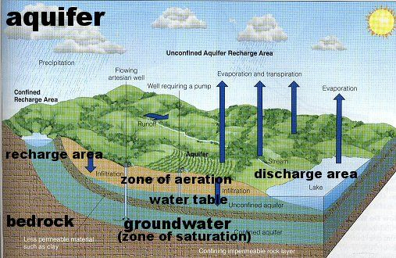

9. Aquifers are sources of usable groundwater. Unsustainable Rate of Use is when extraction exceeds recharge; Groundwater overdraft leads to environmental problems including land subsidence (Mexico city and San Joaquin valley) and saltwater intrusion in coastal areas

10. “Cone of Depression”: may result when groundwater is pumped to the surface faster than it can flow through the aquifer to the well that has been drilled; if (excessive) water removal continues, the water table will fall far below the wells.

11. Saltwater Intrusion: when the water table is lowered due to overpumping of groundwater, the normal interface between fresh and salty water moves inland, making coastal drinking water supplies unusable. Mitigated by putting treated wastewater into injection wells near the coast

12. Aquifers may be confined by bedrock/consolidated rock and/or impermeable clay or unconfined (only soil above them). Unconfined aquifers are more easily contaminated by surface runoff and infiltration/ percolation since the soil above them is permeable to water carrying contaminants. Confined aquifers can cause water pressure to build up and produce artesian springs

13. Ground water pollution and cleanup: Challenging due to Slow Flow (about one meter per year)Dilution of contaminants is Slow; Fewer decomposing bacteria in groundwater compared to surface water; Colder temperature of groundwater slows down chemical reactions that decompose wastes. Nitrates and pesticides from agricultural runoff; gasoline and chemicals from underground storage tanks; unsanitary landfills with leachates are common groundwater pollutants. Groundwater may be pumped out, treated by reverse osmosis and returned to the aquifer

14. Prevention of Groundwater Pollution: Because of its enormous volume, relative inaccessibility, and slow movement, Prevention of Groundwater Contamination is considered the only effective way to protect groundwater resources: Potential ways to do so: Monitor aquifers near landfills and underground tanks; Require leak detection systems for underground tanks used to store hazardous liquids; banning or more strictly regulating disposal of hazardous wastes in deep injection wells and landfills; storing hazardous liquids above ground in tanks or pools with systems that detect and collect leaking liquids.

15. In the US, per capita (per person) water use has leveled off recently due to conservation and water recycling efforts

15. Globally, total water use has increased nine-fold since 1900, due to increased population and industrial use though many people living in LEDC do not have access to clean drinking water

16.The Big 3 Water Use categories (globally):
Agriculture (70%), Power Plants/industry (20%), Municipalities(10%)

17. Floodplain= land next to a river. Rivers naturally flood periodically and deposit nutrients on the soil in the floodplain increasing the soil fertility and productivity. Great for agriculture.

18.Water Scarcity: “Causes”:
A. Dry Climate or high temperatures of climate change B. Drought (no rain)
C. “Water Stress” (increased demand from increasing population)

19. Increasing Freshwater Supplies: A few possibilities
-- Efficiency Improvement & Conservation Approaches: Use Less to accomplish the same
tasks, therefore more potable FW is available for use, such as-
A. Low-flow or dual flush toilets; waterless urinals; low flow shower heads
B. Motion sensors on faucets (turns off when your hand is not under faucet)
C. More efficient irrigation methods (e.g., drip irrigation)
D. Xeriscaping (landscaping with drought tolerant plants)
E. Fixing Leaks in faucets, toilets, pipes
F. Using Water Meters to Monitor and Charge for Municipal Water Use (pay as
you flow), as opposed to a flat-rate approach
G. Capturing and Storing stormwater: Water that would otherwise be lost as runoff-, picking up pollutants before ending up as salt water in the ocean can be captured in rain barrels, cisterns or underground retention tanks, building more reservoirs and dams
H. Bring in More Water from Other Places: importing using aqueducts
I. Withdraw more Groundwater using deeper wells and stronger pumps
J. Convert Saltwater to FW via Desalination
K. Gray Water from bathtubs or washing machines (laundry to landscape) and reclaimed wastewater (purple pipe systems) can be used to irrigate lawns, saving the drinking water for other uses
L. Advanced (tertiary) treatment of wastewater, microfiltration and Reverse Osmosis: remove all pollutants and produce potable water

20. Pros and Cons of large Dams and Reservoirs:
Pros: -Hydroelectric Power Production (Clean and Affordable Energy source)
-Provides water for Year-round use
-Reduction of Downstream Flooding
-Reservoir is Useful for Recreation: Boating, Fishing
Cons: -Large Water Losses due to Evaporation
-Flooding behind Dam submerges Ecosystems and homes
-Downstream Areas are deprived of nutrient-rich silt and water flow
-Migration and Spawning of some fish species such as salmon is disrupted, reducing their population numbers
-sediment build up behind dam and less reaching downstream to replenish beaches

21. Large –Scale Water Transfers (diversion projects) : Aral Sea, Colorado River, California Water Project (system of aqueducts)

22. Ecosystem Services provided by Rivers: examples
-Delivery of Nutrients to the Sea for maintaining ocean productivity
-Deposition of Silt; helps maintain Deltas which buffer inland areas from storms
-Purification of Water by aquatic plants and microbes
-Renewal of/Nourishment of Wetlands
-Provide Habitats for Aquatic Life, maintaining high biodiversity
-floodplains are very fertile so good agricultural land next to rivers

23. Desalination: Pros and Cons
Pros: -Increases Freshwater Supply regardless of droughts
Cons: -Is Expensive due to Large Energy Requirement;
-Produces large quantities of brine waste water: dumping this concentrated
brine into the ocean near the desalination plants increases local salt
concentration, disrupting habitats with increased salinity
*The two most widely used desalination methods:
1. Distillation: saltwater is heated until it evaporates, leaving behind salts;
and condenses as FW.
2. Reverse Osmosis and microfiltration : saltwater is pumped at high pressure through a thin membrane whose pores allow water molecules to pass, but not dissolved salts.

24. LEVEES channel the flow of water; DAMS block the flow of water, RESERVOIRS store water and AQUEDUCTS divert the flow of water

25. LEVEES 1. Prevent natural floodwaters from depositing nutrients on farm land next to river
2. carries sediments to the ocean more rapidly
3. force water farther downstream where it can cause even worse flooding in the next town or when they break as in HURRICANE KATRINA

26. How urban areas impact the water cycle - preventing groundwater recharge due to more impervious surfaces like pavements, roof tops and asphalt; increasing storm water runoff so more flooding and plastic debris or waste reaching surface waters

27. Wastewater treatment and the Clean Water Act: distinguish between primary and secondary treatment; aerobic and anaerobic bacteria; disinfection techniques
-Primary Treatment = Mostly a Mechanical, Physical, Gravitational Process; removes 60% of suspended solids and 30% of the oxygen-demanding organic wastes from sewage; very few phosphates, nitrates, salts, radioisotopes, or pesticides are removed -Secondary Treatment = mostly a Biological Process (disinfection follows with Chlorine, UV lights or Ozone, used in final step, the last thing done before releasing the wastewater to rivers or the ocean); Aerobic bacteria are used to remove up to 90% of the biodegradable, oxygen-demanding organic waste (BOD); facilities use an activated sludge process in which sewage is pumped into a large tank and mixed for several hours with bacteria-rich sludge and air bubbles to facilitate degradation by microorganisms; water then goes to a sedimentation tank, where most of the suspended solids and microorganisms settle out as sludge.
Primary and Secondary Treatment (together) removes about = 97% of the suspended solids, by weight, 95-97% of the oxygen-demanding organic wastes (BOD), 70% of most toxic heavy metals, 70% of phosphates, 50% of nitrates, and 5% of dissolved salts. They do NOT REMOVE HORMONES OR PRESCRIPTION DRUGS OR HEAVY METALS -Tertiary (advanced) Treatment = Chemical and Physical Process to remove the nutrients, hormones, heavy metals and prescription drugs from the water, such as microfiltration and reverse osmosis. Produces potable (drinkable) water or close to it.

-28. As a result of the Clean water Act, most U.S. cities have combined Primary and Secondary Treatment Facilities

- Clean water Act: objective is to restore and maintain the chemical, physical and biological integrity of the nation’s waters. Prevents point and nonpoint pollutions sources. Requires water treatment plants to improve wastewater treatment (must be cleaned twice before release). Applies to wetlands and all water reservoirs

- Safe Drinking Water Act: protects the quality of drinking water from contamination (organic and inorganic chemicals, pathogens and radioactive elements); sets and maintains standards for purifying tap water

29. Wetlands: economic, social and environmental benefits -(shellfish or oyster or fishing industry profits; cheaper filtering of wastewater (duckweed removing nutrients and sediments removing heavy metals; wetlands slow water movement preventing flooding and erosion downstream; definition of a wetland= land under water for a part of the year, with water loving soils and vegetation; sources of non-point pollution in wetlands (agricultural and urban). Wetlands have been drained for agricultural or residential purposes, resulting in over 50% loss of all original wetlands in North America

30. Water Quality of Coastal Wetlands: about 40% of the world’s population lives within 100km (60 miles) of the coast; in many developing nations (and in some developed nations), municipal sewage and industrial wastes are dumped into the ocean without treatment.
About 80% of the sewage from large cities along the Mediterranean Sea (a coastal population of about 200 million during high tourist time) is discharged into the sea untreated.
Many U.S. harbors and bays are polluted with city sewage, industrial wastes, and oil. Divers talk of swimming through clouds of half-dissolved fecal matter and some bay & harbor bottoms are covered with a toxic sediment known as black mayonnaise. Sewage runoff, agricultural waste, acid deposition from the atmosphere, leaking septic tanks, and sometimes sewage treatment plant effluent can be sources of coastal water pollutants.
The introduction of large quantities of nitrate and phosphate, increase algal blooms whose death and are decomposition lowers DO and biodiversity in the water.
Fecal Material introduces colonies of viruses and bacteria and contribute to people developing ear infections, hepatitis A, vomiting, diarrhea, Cholera, Typhoid fever, Polio

31. Positive feedback loop: often called a vicious cycle; happens when changing something about a system sets up a situation where that change is amplified further and further. ONE EXAMPLE- decreasing volume of water body increases evaporation, which further decreases volume of water, as in the Aral Sea. Another example is the pesticide treadmill, where using pesticides cause a need to use even more pesticide as the insects develop resistance. A third is the ice-albedo effect where melted glacial ice allows soil to get hotter and therefore melt more ice (works with sea ice too)

32. Be able to Distinguish between point source and non-point source pollution and give several examples of each

33. Describe agricultural sources of water pollution (fertilizer, pesticides, animal waste and sediments), how they enter surface and groundwater and their effects,
- Sediments increase turbidity, blocks sunlight and lowers primary productivity; may also smother animals living on the ocean floor; sediments increase the water temperature as they absorb heat
- Pesticides (including herbicides) bioaccumulate and biomagnify up the food chain so even a small amount can cause major effects in top predators (egg shell thinning; lowered reproductive rates due to fewer eggs produced or abnormal genitalia; endocrine disruption or HORMONALLY ACTIVE AGENTS (sex reversal- changing of testosterone into estrogen)
- ANIMAL WASTE (manure) AND FERTILIZERS (nutrient enrichment)
  - increased nitrate levels in drinking water-leads to blue-baby syndrome;
  - effects on BOD and creation of hypoxia (low DO) or dead zones;

34. Explain the creation of dead zones (step by step, with all the details included) in coastal waters and lakes by cultural eutrophication:

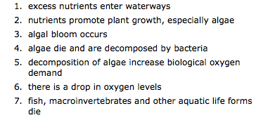
35. BOD- the amount of degradable waste because aerobic bacteria use much of the DO (dissolved oxygen) in the water during decomposition. Examples of BOD include sewage, animal wastes from feedlot runoff, pulp and food processing wastes from industry. High BOD produces a septic zone in the water. Know how BOD is determined (measured)

36. An oxygen sag curve occurs in flowing streams as bacteria break down degradable wastes and deplete the DO in the process. Five zones are: clean, decomposition, septic, recovery and clean. Be able to label a diagram of DO sag.
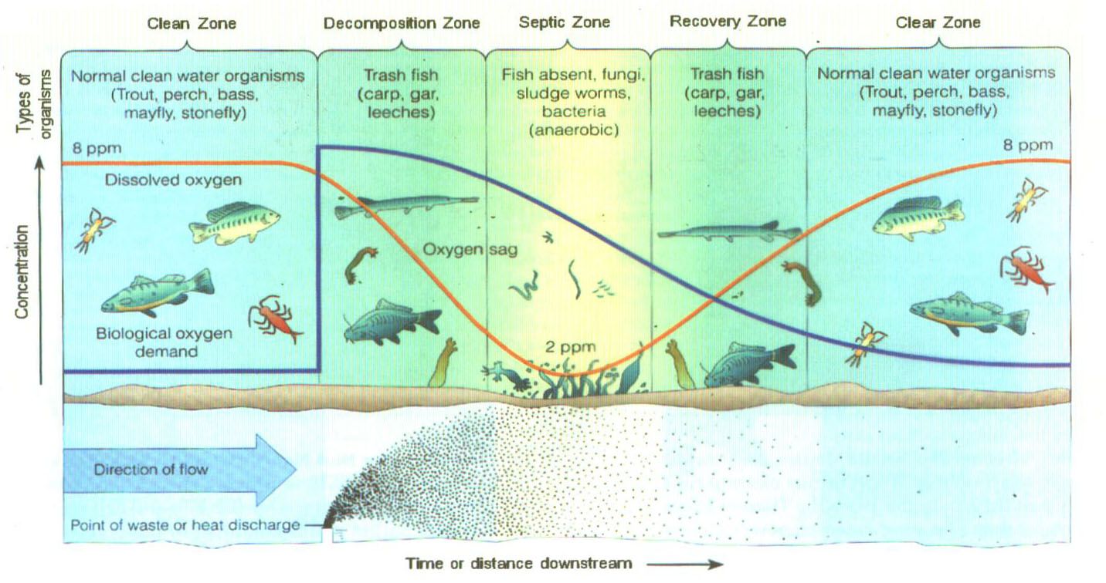

37. Some Water pollution Prevention Approaches:
- Advanced Waste Treatment of sewage before release into the environment;
- Soil Conservation (no till) to reduce sediment or nutrient runoff from farms
- use of clay or plastic liners under landfills to prevent leaks from entering groundwater
- capturing storm water (various methods) before it enters the ocean or lake
- increase recycling and reuse rates to decrease the amount of plastic entering the environment

Water Cleanup Methods: Controlling undesirable water-plant growth with herbicides and algaecides; pumping air through lakes and reservoirs to avoid oxygen depletion; Pump and treat groundwater using Reverse Osmosis. Pollution Prevention is usually more effective and generally less expensive in the long run than cleanup.

38. Water Quality TESTS TO KNOW
Factors/Tests (most are done by adding test tabs (tablets) to a sample of water, waiting for a color change, then matching the color against a standard comparator. Many may be done with a digital sensor). Learn how to do the test and what it indicates!

I. Temperature
Temperature tolerances vary by species. Optimum temp. range is necessary for enzymes to function. Thermal stress and shock can occur when temperatures change more than 1-2 degrees in 24 hrs Sediments (turbidity)can increase stream temperature because they make the water darker in color so it absorbs more light energy. . Thermal Pollution: addition of heat/heated water (typically from a power plant), which results in lowered DO level and resulting “range of tolerance” challenges for organisms. Mitigation: plant Shade trees along the river bank to lower stream temperature
II. Turbidity/Cloudiness
High turbidity levels may damage gills and interfere with food gathering by fish and lower the rate of photosynthesis by bottom dwelling plants because they lower the amount of sunlight reaching the bottom of the pond or lake. Turbidity is caused by sediments suspended in the water. Depth at which you can no longer see through the water is called the secci depth. When the secci depth is more than 1 meter, submerged aquatic vegetation can survive easily. Increased turbidity also increases water temperature because dark colors absorb more light and heat
Mitigation: Buffer strips of vegetation along the river or wetlands trap sediments before they can enter the water
III. pH
A range of 6.5 to 8.2 is optimal for most organisms
Extreme acid and extreme alkaline conditions are hazardous because they interrupt enzyme function in organisms and can cause heavy metals such as Al to leach into the water. Al ions in the water cause fish gills to fill with mucus, resulting in death by suffocation. Low pH also causes loss of calcium and magnesium ions by plants, lowering their primary productivity (photosynthesis)
IV. Dissolved Oxygen (DO)
A dissolved oxygen level below 3ppm is stressful to most aquatic organisms
DO of 8-9 is very good, below 5 is gravely polluted. Oxygen is necessary for aerobic respiration of all aquatic animals
Mitigation: lower the BOD in the water. Using lined retention ponds for manure, treating waste in sewage treatment plants both lower BOD.
V. NUTRIENTS:
(i) Nitrate/Nitrogen
Levels above 10ppm considered unsafe for drinking water, results in BLUE BABY syndrome
Unpolluted water has level below 1 ppm
Excess nitrogen results in increase algal blooms in surface water, which then cause cultural eutrophication (learn to describe the process of eutrophication in detail)
(ii) Phosphate
Total phosphorus levels higher than 0.03 ppm contribute to increased plant growth as phosphorus is often a limiting factor in growth. Levels above 0.1 ppm can also cause cultural eutrophication
Mitigation: construct wetlands to absorb the nutrients before they enter surface waters. Monitor the amount of fertilizer used on farms to use only the amount the crops can absorb. Use retention ponds or waste lagoons lined with clay to prevent the nutrients infiltrating the soil.
VI. Hardness
Defined as the amount of calcium and magnesium (primarily), both of which enter the water mainly by leaching from rocks, especially if the water is acidic
Hard water = high amounts of Ca²⁺ and Mg2+ cations
Soft water = low amounts of Ca²⁺ and Mg ²⁺
VIII. Fecal Coliform Bacteria
Permissible fecal coliform levels are lowest for drinking water/well water (1 cell/100mL of water), a little higher for swimming (200 cells/100mL of water), and the highest for boating and fishing. Presence of coliform indicates that animal wastes, including pet waste not picked up by owners or animal feedlot waste, or untreated sewage has entered the water.
Mitigation: Provide bags in parks for pet waste; plant trees/buffer strip alongside rivers or construct wetlands to prevent waste entering the water; build more wastewater treatment plants
IX. Salinity
Defined as the total of all salts dissolved in the water (TDS). Dissolved solids are measured by conductivity tests. Salinization of soils from industrial agriculture is one cause, where the water in the fields evaporate leaving salts behind. Salt from roads in northern states also are carried into streams by runoff. Tidal changes can push salt water further inland in an estuary. Saltwater intrusion of groundwater can push salty water into freshwater aquifers. High salinity levels interfere with the osmotic balance of plants and aquatic animals
Seawater = 35 ppt (parts per thousand), freshwater = 0 ppt
Mitigation: flush fields with plenty of freshwater
X. Carbon Dioxide
Above 25 ppm is harmful to most gill breathers. Carbon dioxide dissolves in water to form carbonic acid that acidifies the ocean, leading to coral reef loss when the acid reacts with the calcium carbonate shells
Mitigation: stop deforestation so that plants can remove carbon dioxide from the air; reduce the amount of carbon dioxide produced by combustion in cars, power plants and factories, using renewable energy sources such as solar or wind energy or hydroelectricity

Pollution Tolerance Index (PTI):
The Pollution Tolerance Index is based on the concept of indicator organisms and tolerance levels. Indicator organisms are those organisms that are sensitive to water quality changes and respond in predictable ways to changes in their environment. Therefore, their presence or absence indicates something about water quality. Mayflies, caddisflies and stoneflies are indicator species will a low tolerance for water pollution. Their presence indicates good quality. Their numbers decrease sharply with pollution. Higly polluted water will have mostly worms and leeches because they are very tolerant species. The lowering of biodiversity tells you that a pollutant is present but does NOT tell you which pollutant!

40. TRAGEDY OF THE COMMONS: short term gain over long term sustainability
- COMMONS are resources available for human use. Examples include
  - AIR
  - OCEANS
  - SURFACE AND GROUND WATER RESOURCES
  - MINERALS
  - ANIMAL resources
- These resources are for human use but some people exploit them more than others. Such self-interest make some people rich. The price of depleting the resources of the commons is an external cost paid by all people of earth (an EXTERNALITY to the company that does the exploiting). Government subsidies often lead to exploitation of resources since the price to the owner is offset by taxpayers
- Examples of current environmental problems considered a tragedy of the commons include: uncontrolled human population growth leading to overpopulation
    - Air pollution from fossil fuels
    - Mining of groundwater and over diversion of surface water
    - Habitat destruction and poaching
    - Overfishing- techniques such as bottom trawling, long-lining and purse seining all harvest enormous amount of fish, including unwanted species called BYCATCH. Bottom trawling also destroys habitat by scraping nets against the ocean floor, raising large amounts of sediment pollution; long-lining and purse seining catches turtles, birds and other bycatch;
Unsustainable fishing techniques: 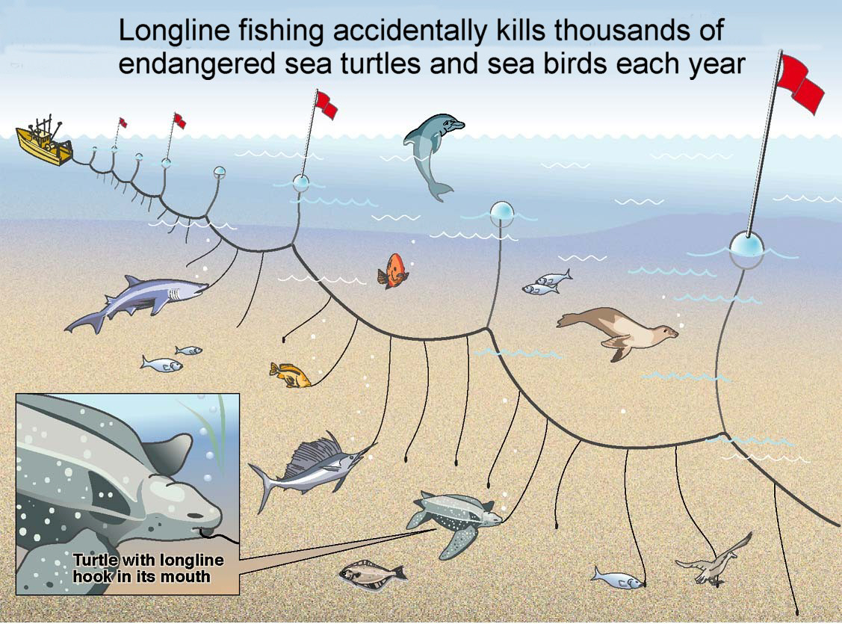

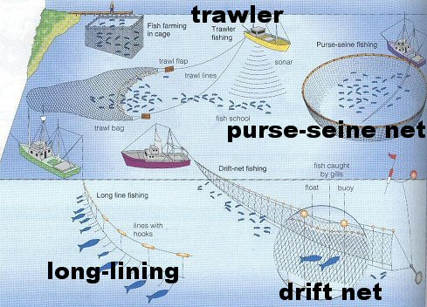
- One solution to the tragedy of the commons has been to PRIVATIZE public resources. Another solution is to implement a CAP AND TRADE or QUOTA SYSTEM, where each stakeholder is allocated only a certain amount of the resource to use.

41. KNOW THE DIFFERENCE BETWEEN OLIGOTROPHIC AND EUTROPHIC!

42. PHOSPHORUS CYCLE
• _Phosphorus is required in the form of phosphate ions for nucleic acids, ATP, phospholipids in cell membranes, bones, teeth, shells of animals.
• _PO₄³⁻ = Phosphate
• _Is a sedimentary cycle - does not include the atmosphere.
• _Phosphate on land and in ocean sediment is released by weathering into water and taken up by plants. Can be limiting factor for plant growth - is present in artificial fertilizer.
• _Animals get phosphorus by eating plants or other animals.
• _Decomposition changes organic molecules with phosphorus back into phosphate, which dissolves in water which returns the phosphorus to ocean sediment or deposited as rocks.
• _Human intervention:
o Mining of phosphate for fertilizers and soap causes disruption to ecosystems.
o Removal of phosphorus from ecosystems by cutting down of vegetation. Most of phosphorus is taken up as biomass.
o Excessive phosphate in runoff from fertilizer, discharge of sewage, farm waste

NITROGEN CYCLE (see below- page 30 of this document)

43. Trophic levels and energy pyramids:
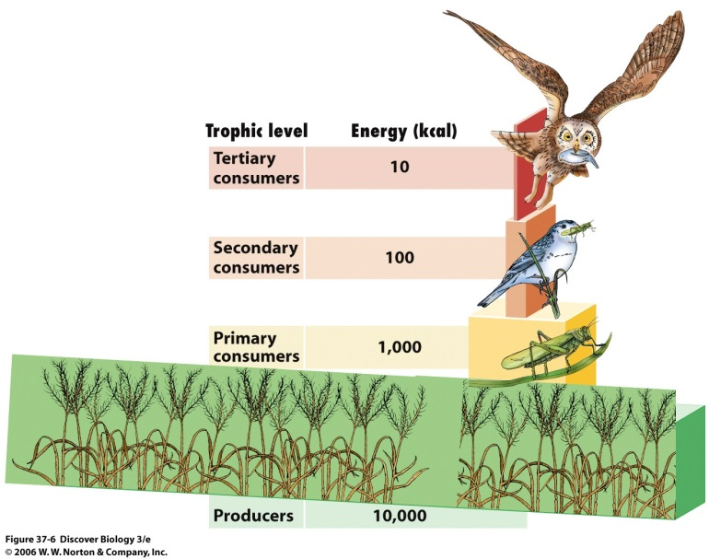

Know how to draw a food chain (arrow means “is eaten by”) and that only 10% of the energy from one level is passed on the next. The rest is lost as heat. This is the 2nd law of thermodynamics and explains why it costs more to produce and buy a pound of meat than a pound of corn. More people can be supported as vegans than as omnivores using the same amount of land. Decomposers (bacteria, fungi) break down non-living matter into simpler constituents, recycling nutrients back to the producers

44. Photosynthesis is the process by which green plants use the chlorophyll in their cells to capture light from the sun and use it to combine carbon dioxide and water to make glucose and oxygen.

RESPIRATION is the process used by aerobic organisms to break down sugars and convert the energy in them to produce ATP (chemical) energy to power their cells. Carbon dioxide is released

PRIMARY PRODUCTIVITY is a measure of the energy available in an ecosystem.
- GROSS primary productivity it the total amount of the sun’s energy that plants convert to biomass (organic material)
- NET primary productivity is the amount of energy available to consumers after the plants use some for respiration

NPP = GPP – Respiration. This can be done in the lab by measuring the DO of aquatic plants. Keeping the plants in the dark will show how much DO is used by respiration. Keeping the plants in the light shows how much DO is produced by Gross primary production.

45. Only 1% of the incoming solar energy is used by plants for photosynthesis!!!! This is the 2nd law of thermodynamics.

46. Keystone species have strong or wide-ranging impacts in their ecosystem, far out of proportion to their actual abundance. A small predator that prevents an herbivore from decimating a particular plant is frequently considered a keystone species. Starfishes, Sea Otters and wolves are examples of keystone species

47. Indicator species are organisms that indicate whether or not disease-causing pathogens are likely to be present. The best indicators for potentially harmful water are fecal coliform bacteria, a group of bacteria (such as E. coli) that live in the intestines of humans and other animals. They enter the water through feces.

48. KNOW THE SYMBIOTIC RELATIONSHIPS AMONG SPECIES:
- Mutualism : both organisms benefit from the relationship
- Commensalism: one organism benefits and the other is not affected
- Parasitism: one organism benefits and the other is harmed

49. Primary succession: plants and animals gradually invade a region that is newly created where soil has not yet formed, such as after a glacier retreats or volcanic lava spreads across a landscape. PIONEER species such as lichens and moss begin the succession. Primary succession ends with a climax community

Secondary succession: occurs after an existing community was cleared out by fire, farming or landslide; however the soil was left intact. The end of all succession is the CLIMAX. The climax community depends on the biome of the region which is itself a consequence of the amount of rain and the temperature of the region.
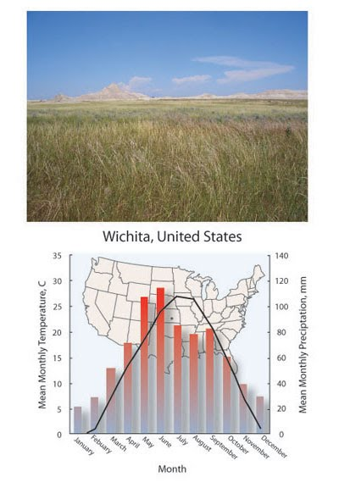

50. BIODIVERSITY of an ecosystem is threatened by habitat loss and invasive species. Globally, tropical rainforests are experiencing the greatest habitat loss.
The ENDANGERED SPECIES ACT is the prime legislation protecting biodiversity in the US. It forbids actions that destroy endangered species or their habitats or trading/selling them. CITES TREATY is international protection of endangered species. Prevents trading them.

Biodiversity is important because:
- Genetic diversity confers resistance to epidemic diseases because some individuals will always be resistant and survive (ensuring the species as a whole will survive). Genes may also be considered a resource for artificial selection and breeding of crops as well as for recombinant DNA in the creation of GMOs.
- Individual species are part of the food chain, removing them can destroy the entire ecosystem.
- Resources for human use are a result of biodiversity- many medicines, food and building materials are discovered and are still be discovered from diverse ecosystems.
- Aesthetic/ cultural/ religious value- some areas or animals have special significance to many cultures (such as the cow to Hindus)
- Economic value- ecotourism, wildlife viewing and photography, recreational activities such as fishing, kayaking, rafting and hiking all depend on biodiversity to attract people who pay for licenses, tours and accommodations.
- Special case: pollinators! Bees, bats, moths and various insects like butterflies, perform a service when they pollinate plants. This can be an agricultural service or a natural one. In both case they help increase the population of trees and other plants.

51. AGRICULTURE AND ITS EFFECTS ON THE ENVIRONMENT:
A healthy diet generally requires around 2000 calories per day. Wheat, rice and corn supply over half of human caloric intake; It takes 15kg of grain to produce 1kg of meat, mostly consumed in the More Economically Developed Countries. By consuming the grain directly instead of consuming the animals that feed upon it, there would be a tremendous increase in the amount of calories available. However, the benefit of consuming meat is that it is a concentrated source of protein and many micronutrients.
In the US corn is grown primarily as animal feed

A. soil quality and land degradation
B. water quality
C. Air quality
D. Biodiversity
E. human health

- SOIL: four components- minerals, humus, air and water
- 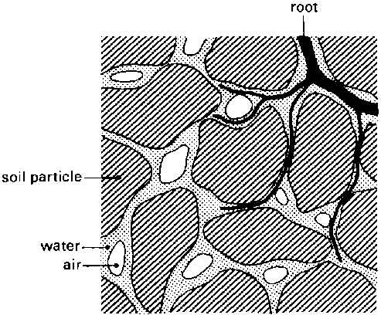 minerals may be clay, silt, sand or gravel sized particles. Air and water sits between particles in pore spaces
- SOIL HORIZONS: show how the soil develops from bedrock
- 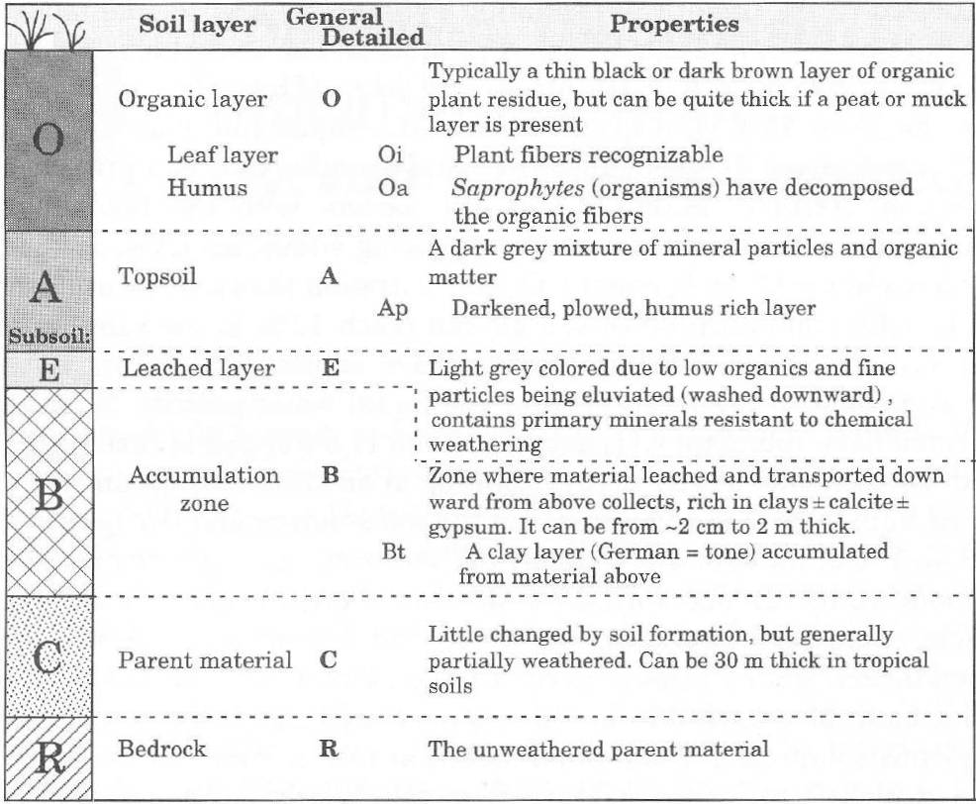
Topsoil (A layer) is the layer in which crops grow (agriculture affects this layer the most). The O layer is the layer of leaf litter and decomposing organic matter that adds nutrients to soil. It also aids in water retention, increases porosity and prevents soil erosion. Rain washes many minerals from the topsoil and deposits them in the B layer, just outside of many roots. AGRICULTURAL TILLING REMOVES HUMUS from the topsoil, causing soil degradation as the particles dry out and erode. Sediments that end up in surface waters create turbidity, lower primary productivity and increase water temperature AFFECTING WATER QUALITY.

- PHYSICAL ROPERTIES OF SOIL: porosity and permeability and texture
  - Porosity is the amount of pore space between particles
    - Gravel has the most pore space
  - Permeability is the extent to which water can pass through the soil. Pores must be connected for permeability to be high.
    - Gravel has the highest permeability. Clay has the lowest.
    - 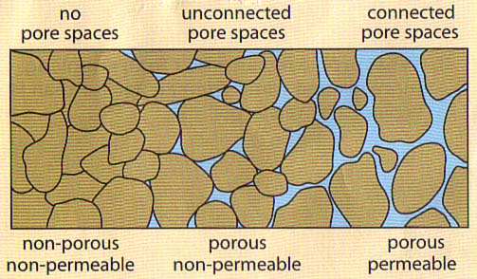
  - Texture is the relative amount of particle sizes in the topsoil. Clay is the smallest particle size, followed by silt, then sand. Gravel is the largest particle. Most soils are a mixture of sand, silt and clay (loam).
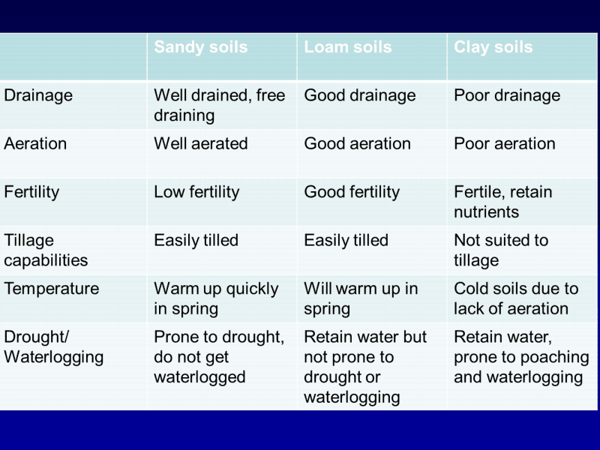

- CHEMICAL PROPERTIES OF SOIL: fertility, pH, CEC and salinity
  - The amount and types of nutrients in the soil is fertility. Nitrates, phosphates, potassium (N<P<K) and micronutrients such as iron, magnesium, sulfur and essential for plant growth.
    - Nutrients may be added to topsoil as inorganic fertilizer, manure or mulch, or humus may be left to decay in place.
      - Excess fertilizer (not taken up by plants) is moved during rain as agricultural runoff and AFFECT WATER QUALITY. If it enters surface water, it will cause an algal bloom, which increases BOD and lowers DO levels below 2ppm (cultural eutrophication). A dead zone follows since most fish require 6-8ppm of oxygen to survive.
      - Nitrates that percolate into groundwater during rain will not be decomposed and can AFFECT HUMAN HEALTH if the water is used for drinking. Blue baby syndrome in humans occurs as nitrates are converted to nitrites in the blood, create methemoglobin and may result in death as the blood cells are no longer able to carry oxygen.
      - Denitrification of excess nitrates can lead to increased levels of nitrous oxide, a greenhouse gas AFFECTING CLIMATE CHANGE
  - pH affects which minerals will leach from the soil. Low pH (acidic conditions) cause heavy metals to leach and enter run off water. (look up the effects of heavy metals such as Aluminum on fish in your power point notes) Acidic water can also leach lighter metals from the soil, such as Ca²⁺ and Mg²⁺ which will lower plant productivity (affects photosynthesis)
  - Salinity is the measure of dissolved salts in the water. All natural surface waters contain salts that become concentrated if the water evaporates. Irrigation for agriculture can increase the salinity of the soil if the water is evaporated in the field, which happens when the watering is very shallow.
  - Cation Exchange Capacity (CEC) affects the availability of nutrients in the soil. A high CEC means the soil is negatively charged, probably rich in clay, and so able to hold more nutrient cations like potassium, calcium and magnesium. High CEC means there will be more nutrients available to the plants.
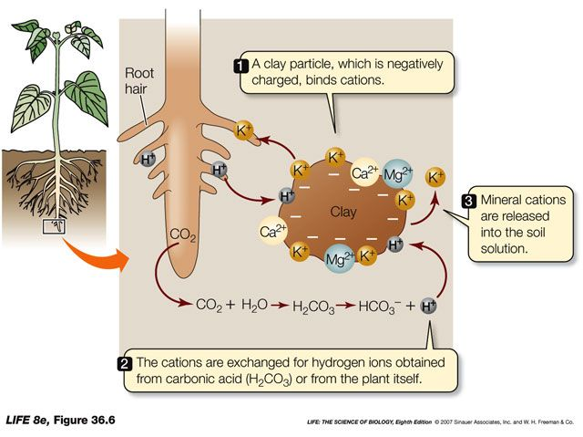
- REVIEW STRATEGIES FOR PREVENTING SOIL EROSION AND DESERTIFICATION

52. Controlling pests: MONOCROPPING MAKES CROPS VULNERABLE TO PESTS
- Herbicide- used to kill or control weeds that compete with crops
- Fungicides- used to kill or control fungus and molds that attack crops
- Insecticide- use to kill or control insects that consume crops, lowering yield
- Rodenticide- used to kill or control rodents (mostly rats and mice)

PROBLEMS WITH PESTICIDES-
- Broad spectrum pesticides (such as organophosphates and organochlorines like DDT) can kill many different types of insects, including non-target insects such as pollinators or predators of pests. Killing pest predators can lead to increased pest infestation since the eggs or pests will hatch (even after spraying) and there will be no natural predators to keep the pest population in check. This forces the farmers to use more pesticides leading to a pesticide treadmill and incurs more cost and more potential for environmental contamination.

- The development of insecticide resistance- genetic diversity in every population means that some insects will have genes that give them resistance to certain pesticides. When the pesticide is sprayed, all susceptible insects die off, but the resistant individuals remain to reproduce. They reproduction increases the population of insects again but now they are all resistant to the pesticide and are not killed by repeated sprayings with that same pesticide. Farmers must then find a new pesticide to use to prevent crop loss by pests, further increasing the pesticide treadmill.

- Secondary pests can be created by pesticides if the natural enemies, predators or parasites, of an insect were killed by pesticides, allowing it to spread unchecked OR if the competitors or prey of the insect pest are suddenly freed by its death in the ecosystem, allowing them to flourish and become pests themselves.

- Persistence of organochlorines, like DDT, means that the effects of the pesticide will remain for very long periods in soil or water. This limits the future use of the land (for example, excessive use of herbicides will make it impossible to use the land for agriculture later on; synthetic pesticides make it impossible to use the land for organic farming). Persistence in water means increased exposure of aquatic animals, leading to lower biodiversity of aquatic ecosystems as macroinvertebrates die and disrupt the food chain, or bioaccumulate in fats and oils of prey species. Population of bald eagles, osprey and the pelican are affected when they feed on fish that may have bioaccumulated and biomagnified DDT. Birds are not killed outright but the pesticide interferes with their ability to metabolize calcium and they produce eggs with very thin shells. Thus their offspring do not survive and the bird population is lowered.

  - Distinguish between bioaccumulation and biomagnification and relate this to pesticide poisoning.
    - Biomagnification refers to the increase in concentration in the body tissue of organisms in a food chain or food web as you move up trophic levels; e.g., PCBs, DDT, Hg, Pb, radioisotopes, can be stored in body tissue when consumed; phytoplanktonzooplanktonrainbow smeltLake TroutHerring Gull.
    - Biomagnification is synonymous with Bioamplification.

  - Bioaccumulation refers to the build-up of a given substance in the fatty tissues of a single organism over the course of its lifetime; e.g., a bluefin tuna may build up concentrations of PCBs in its body tissues over time, since PCBs are not metabolized as food nutrients would be; Bioaccumulation is synonymous with Bioconcentration.

- Pesticides can drift on the wind or enter surface and groundwater sources by agricultural runoff from farms. Pesticides may drift as far as the Arctic region by the grasshopper method (being carried by wind, then dropped, then vaporizing and carried by wind again, the cycle repeating itself until the pesticide ends up in the Arctic)

- Effect on human health- may lead to pesticide poisoning in Less Developed countries where precautions, such as protective clothing, are not taken when using pesticides and it is inhaled or ingested. Organochlorines can cause spasms and respiratory distress. They can bioaccumulate in humans, especially in breast milk and be passed on to offspring. They are suspected carcinogens.

- Effect on wildlife- may lead to hormone disruption that results in the feminization of frogs; genital abnormalities and low egg production in several species of birds and alligators; thinning of egg shells

  - BEE COLONY COLLAPSE and MONARCH BUTTERFLY DECLINE may be due to the class of pesticides called NEONICOTINOIDS. Bees are important pollinators and are needed for agriculture. Bees pollinate 1/3 of all produce in the US, an ecosystem service worth billions of dollars!

53. Rachel Carson: author of the book ‘Silent Spring’ raised public awareness of the environmental consequences of DDT use

54. Pesticides that have been banned in one country may still be used or exported to other countries where they can be legally applied to crops. The crops are then harvested and exported to the US for consumption. This practice exposes residents to the banned pesticide and is known as the circle of poison. Also migratory birds can still become affected by DDT in their travels

55. Integrated Pest management (IPM) as an ALTERNATIVE TO PESTICIDE USE: the goal is not to eradicate the pest only to reduce their numbers to economically tolerable levels. Controlling pests allow greater crop yields on less land. This is accomplished through the combination of complementary pest management strategies that include physical or design methods, biological methods and use chemical methods only when absolutely necessary.
I. Design methods- window and door screens, draining swamps or fountains, crop rotation, GM crops for insect or herbicide resistance, intercropping with plants that repel certain pests by odor such as marigolds and chrysanthemums
II. Physical-Mechanical methods- traps, with or without pheromones, bed nets, long sleeve clothing; improved sanitation; applying mulch to deter pests
III. Biological control- use of natural enemies such as parasites or predators (parasitoid wasps), Bt toxin, lady bugs to eat mites and aphids; spiders, frogs, dragon flies to eat mosquitoes. Biological control can go wrong if the introduced species becomes a pest itself, with no natural predator of its own. For example the CANE TOAD in Australia. The life cycle of the toad was not synchronized with the cane beetles it was supposed to control. The toads became a pest to many native species. Also MONGOOSES in Hawaii were brought in to control rodents but rodents are active at night and mongooses hunt during the day. So the mongooses preyed upon native birds instead.
IV. Chemical pesticides- most risky and unsustainable part of pest management. Low risk includes DEET, pyrethroids, neem oil, off. Higher risk include DDT, parathion. Chemicals may be needed if the infestation of pests is too great and an immediate reduction in their population is necessary, such as during a West Nile, malaria or Zika outbreak.

56. Be able to describe an IPM for a given pest, such as the mosquito or European Corn Borer. Your IPM must include something from all levels of the pyramid.

57. Genetically Modified organisms: GMOs are all transgenic, in that the DNA from other species have been spliced into the food using recombinant DNA technology. The goal is to place genes for desirable traits such as disease and pest resistance into the crops. (genes as resource). This lessens the need for pesticides or protects the crops from herbicides used to kill pests. Most of the corn and soybeans grown in the US are GMOs. Soybean is the largest GM crop grown, by hectare
- CONS- transgenes from GM crops might escape into nature, cross-pollinating with non GM crops, lowering biodiversity (genetic contamination)
  - Pests might develop resistance to the GM crops and become ‘super-pests’
  - Herbicide tolerant crops tend to result in more herbicide use as farmers freely apply additional herbicide since their crops can withstand it. Herbicides then enter surface water in runoff and lower primary productivity AND cause the feminization of frogs and other the reduction of reproductive success of alligators and birds
  - GM foods may cause allergic reactions in humans or have unintended (and unforeseen) consequences on natural ecosystems such as lower genetic diversity of wild plants through spreading of the GM genes
These disadvantages may be mitigated by keeping a buffer zone of wild plants around the farm growing GM crops. The wild types will mate with the GM varieties and slow the spread of their genes.
- PROS- because farmers do not have to till to control weeds, GMO can promote soil conservation
  - Reduces need/cost for chemical pesticides (no pesticide treadmill or public health risks from pesticide spraying either)
  - Drought tolerant crops save on water needed for irrigation.
  - High yield crops reduce the need for more land clearing or deforestation, making agriculture more efficient
  - Enriched GM crops such as Golden Rice can supply more nutrients to impoverished families, improving public health and lowering death rates
  - Lower the price of food since there is less water and pesticide needed and the yields (supply) is higher

58. Be able to Describe methods of soil conservation (controlling soil erosion) such as contour plowing and terracing; no till agriculture; drip irrigation; agroforestry (shelter belts); crop rotation; intercropping (see powerpoint notes and text)

59. Be able to describe the advantages of inorganic and organic fertilizers (see powerpoint)
60. Be able to describe the causes and solution to desertification. Know where desertification is occurring in the world (see powerpoint)

61. Prevention and Reduction of Surface Water Pollution from Agriculture: Reduce fertilizer runoff by only applying what is needed; Use of Slow-Release fertilizer or mulch or humus; Use No fertilizer on sloped land; Crop Rotation (use of nitrogen-fixing crop plants such as legumes during one growing season, then using same land for crops the next season) intercropping or polycropping (growing more than one crop simultaneously) ; Plant Buffer Zones of Vegetation between cultivated fields and nearby surface water; Use of Biological Control/IPM to reduce pesticide use; for Animal Feedlot Manure: Improve Manure Control by planting Buffer Zones or retention ponds that are lined with plastic or clay, Not locating feedlots and animal wastes on steeply sloped land near surface water; Reforestation of Critical Watersheds (so that trees act as windbreaks and roots anchor soil, leaf litter adds humus)

62. CAFO: Concentrated Animal Feeding Operations- includes livestock and fisheries (aquaculture)
Benefits of livestock include supplying protein and essential micronutrients such as calcium and iron. Livestock provides food, fuel and transport to many local farmers. In some cases, livestock can function as biological control agents in an IPM.

CAFO are industrial scale livestock rearing. They are also known as feedlots. Thousands of animals are raised in relatively small land areas, fed by grain or other industrial by-products that are purchased elsewhere (as opposed to free range animals which graze on many acres).

- PROS-
  - feedlots use less land area so arable land is conserved and can be used for other purposes. For every hectare of land, huge quantities of protein can be harvested.
  - The manure from feedlots can be used as fertilizer for crops or used in a digester to produce methane gas for production of electricity
- CONS-
  - the high density of animals promote the transmission of disease, such as foot and mouth disease or mad cow disease. Disease may also be a consequence of a high grain diet. Farmers use antibiotics to treat the diseases. Though these do not pose a human health threat, the effect of antibiotics released to the environment in animal waste is cause for concern.
  - Feedlot animals are also fed with steroid hormones to increase their muscle mass. Again, this is released in the animal waste to the environment where its effect on aquatic organisms is unknown.
  - A large amount of manure and methane (a greenhouse gas) is produced from high-density feedlots. The nitrogen and phosphorus nutrients in waste cause cultural eutrophication of surface waters. This is especially true of fisheries where the wastes cause dead zones in the surrounding ocean, lowering marine biodiversity. Diseases may also be transmitted to wild stocks.
  - Feedlots keep animals in high density and they are grain fed rather than grass fed. Most of the grain grown in the US is for livestock feed. This drives up the price of food for human consumption.

63. Know the difference between exponential and logistic growth and be able to identify the lag phase and carrying capacity (K) from the graph or data table
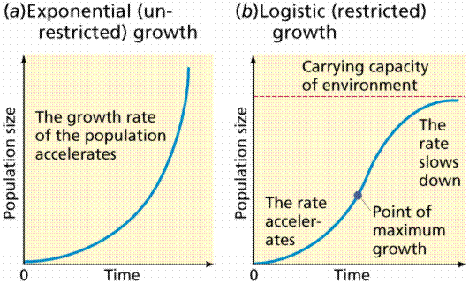
64. Contrast density dependent and density independent population controls and name two examples of each:
- Density independent population controls are natural disasters. Examples include hurricanes, volcanic eruptions, forest fires and so on. They affect a population regardless of its size
- Density dependent population controls are factors that arise from increased crowding such as spread of disease, completion for food and space, spread of parasites

65. Describe the characteristics of r-selected species (think YOLO) and K selected species (parental care)

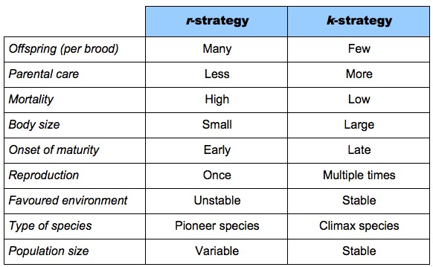
66. Describe why K selected species may be more vulnerable to extinction when environmental conditions change

67. Be able to read survivorship curves and give an example of an organism for each type. Remember-r strategists would be type III and K strategists are type I. Study the graph below;

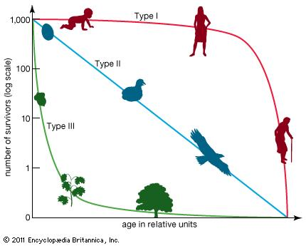
68. Write the basic equations for calculating population density and population growth change and be able to apply them.

69. ZPG stands for zero population growth where birth rate equals death rate. In the demographic transition, pre-industrial (stage 1) and post industrialized (stage 4) countries have near zero population growth.

70. Crude birth rate is the number of births per thousand people. Crude death rate is the number of deaths per thousand people. To calculate the annual rate of population change for each region subtract CDR from CBR and convert to percent. For example ;
in Africa: crude birth rate is 38; crude death rate is 14 = 24/1000 =2.4%

71. Currently, globally growth rate is approximately 1.1%.

72. Know the equation for doubling time, also known as the rule of 70!
Doubling time= 70 ÷ percent growth rate

Sample question: assuming the per capita demand remains the same, what will be the approximate demand for power in Fremont Center in 40 years?
Given that the growth rate of 3.5%; population size of 200,000 and per capita demand for power at 5kW
Solution:
- Figure out the population size in 40 years by using the % growth rate and the rule of 70
    - 70 ÷ 3.5% = 20 years to double in size
    - therefore, after 20 years the population is 400,000
    - after 40 years the population would be 800,000 (double 400,000)
2. Then, use the per capita number to calculate the amount of power demanded by the entire population
- 800,000 x 5kW = 4,000,000 kW or 4,000 MW

73. The three most populous nations: _China, India and USA at 1.3b; 1.2b; and 300 million people respectively. China has a very low population growth rate (0.5%) due to its one child policy but its population is still large. This is due to population momentum, where the many women of childbearing age still giving birth to just one child still increases the population size. India will surpass China as the world’s most populous country by 2050 due to its higher growth rate

74. Demographic transition process from pre-industrial to post industrial society takes place in 4 stages (notice the death rate is the first to fall):

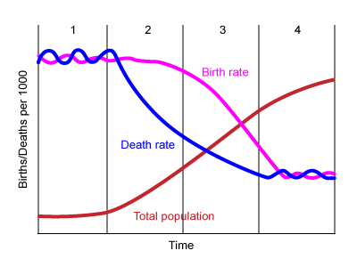
stage 1 (pre-industrial)= high birth rate and high death rate; zero population growth
stage 2 (transition) = death rates drop drastically due to better medical care (including vaccinations), sanitation and nutrition. Birth rates remain high so population grows rapidly.
Stage 3 (industrialized) = birth rates drop due to increased education for women, access to contraceptives and abortions. Population growth slows
Stage 4 (post-industrial) = low death rates and low birth rates. Zero population growth.

75. Total fertility rate (TFR) is the average number of children born to a woman in her lifetime. Replacement fertility is the average number of children a couple must bear to replace themselves in the population. The average RF is slightly higher than 2 children per couple because some children die before reaching reproductive age. The replacement rate is currently at 2.1

76. The TFR tend to be higher in LEDC since there is higher infant mortality so women have many children to replace the ones that do not survive
Improved medical care (reducing infant mortality), increasing urbanization (no need for so many children to work the farm) and greater educational opportunities for women have recently pushed the TFR downward in many nations.

77. Population Age Structure diagrams: the distribution of males and females in different age groups. Useful in predicting future growth or decline of a population. It can also be used to indicate social or economic conditions in a country:
Pyramid age structure may indicate high birth and infant mortality rates, poor health care, a cultural preference for large families or lack of education for women. This shape is typical of less developed countries. The wide base indicates a population will GROW because a large number of females 0 to 15 have yet to give birth. There is simply an increasing number of women who can give birth in the future. Government incentives to decrease the birth rate include subsidizing education for women to delay childbirth (lowering TFR); passing out condoms or other prophylactics; making abortions available; making family planning services available
Column age structure may indicate low population momentum, improved medical care, high education rates for women and the industrialization of the nation. The population growth is slow or stable with few people dying at any age and few people being born
Inverted pyramid age structure may indicate negative population growth and may indicate the need for incentives to encourage people to start families or encourage immigration. Incentives include tax breaks or government subsidized education or housing for families. Italy, Germany and Russia show this shape.
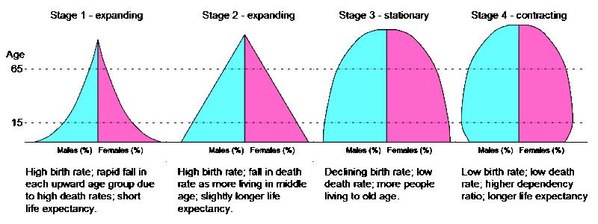

78.Be familiar with CHINA’S ONE CHILD POLICY:
- Implemented in the 1970s; women were sterilized or outfitted with IUDs immediately after giving birth to their first child
- PRO: Decreased the country’s total fertility rate from nearly 6 to less than 2 children per woman in approximately 35 years (one generation)
- CON: Concerns over human rights violations associated with the penalties and treatment of those who violate the policy. Other disadvantages include a cultural perception of male children being more desirable and results in a society with more men than women reaching reproductive age. In this society males take care of their elderly parents and so there is an economic burden on the males (1-2-4)

79. I=PAT : the impact of a population depends on its size (P), the affluence of the people (A) and technology use (T). Middle class people use more resources in order to maintain their social status (standard of living), adding a burden to the environment. Nonetheless, the fastest growth rate is occurring in developing countries such as India. This increases the number of people living in poverty and the chances of environmental degradation of forests for firewood or small scale farming; degradation of fisheries, soils and waterways as a result of attempts to survive.

80. Be able to recognize the first and second law of thermodynamics in examples.

81. Know that electricity is produced when a turbine linked to a generator is spun. The spinning turbine turns the magnet around inside a coil of wire in the generator, inducing an electric current (movement of electrons). Most power plants use steam to turn the turbine. The differences come from how the steam is made/generated.

82. The majority of commercial energy is provided by fossil fuels. Fossil fuels are nonrenewable because they take millions of years to form and cannot be replenished at a rate equal to the rate of use. Nuclear power is also nonrenewable.

83. The stages of coal formation in order and the energy and energy content of each rank are peat, lignite, sub-bituminous, bituminous and anthracite. (Please Leave Some Bread for Aundia)

84. Mountain top removal strip mining technique: disadvantages include increase risk of floods and soil erosion due to the removal of vegetation from the mountain; toxic wastewater being stored in the sludge dam at the mine site; acid mine drainage from the interaction of sulfur compounds (iron pyrite) with water and oxygen to form sulfuric acid; massive habitat destruction and loss of biodiversity

85. Surface Mining Control and Reclamation Act (SMCRA) required land be restored to support pre-mining use. This includes disposal of all mining waste, re-contouring the land as closely as possible to the original slope, replanting vegetation and then monitoring for years after.

86. Know how Acid rain forms from coal burning, its specific environmental effects (on plants and fish and people’s respiratory systems) and ways to mitigate (see powerpoint)
Also know that-
- Normal rain is pH 5.6 due to carbon dioxide dissolving in rain water (natural)
- Acid rain is much lower, pH 4.6 or so due to sulfur dioxide and nitrous oxide pollutants from the combustion of fossil fuels by cars, power plants and some industrial facilities.
- The severity of acid rain depends on the acid-neutralizing or buffering capacity of the soil or water that receives it. Soils containing limestone are good buffers.

87. Burning coal produces sulfur dioxide (Sox), nitrous oxide (NOx), CO, LEAD, particulate matter and carbon dioxide as primary AIR pollutants. Know the environmental effects of each gas. Be able to describe one way to minimize the emissions of each gas through the use of:
- Scrubbers- for sulfur dioxide and heavy metals
- Electrostatic precipitators- for heavy metals and solid matter particulates
- Fluidized combustion chambers- for sulfur dioxide and NO_{x}
- Cap and trade systems- for sulfur and possibly carbon dioxide
- Carbon capture and sequestration- for carbon dioxide
- Anthracite- lowers sulfur emissions
Review the powerpoint notes

Burning coal produces HEAVY METALS SUCH AS MERCURY AND CADMIUM as SOLID waste (particulates) in the ash. This is usually sent to landfills and becomes a pollutant in soil or as part of the landfill leachate after it rains. Inorganic mercury becomes methyl mercury by bacteria in the soil and crosses the cell membranes of animals, such as fish, easily. Mercury is bioaccumulated and biomagnified up the food chain. It causes learning disabilities and damaged brain cells in young children. Cadmium increases the risk of heart disease. Reducing the emissions of mercury by capturing it during burning in coal powered plants is one mitigation strategy. ELECTROSTATIC PRECIPITAOTRS and SCRUBBERS can remove heavy metals from the ash produced when burning coal.

Secondary Air Pollutants are ozone, sulfuric and nitric acids, photochemical smog. These are formed when the primary pollutants react with oxygen and water in the air, often under the influence of UV light from the sun.
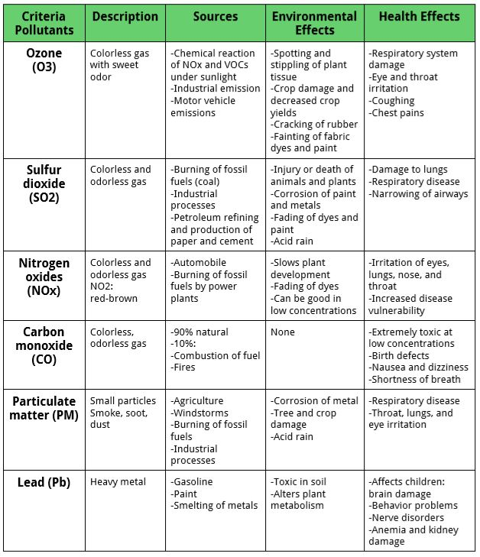
88. Allowance trading aka cap and trade solutions to air pollution: The Environmental Protection Agency grants utility companies tradable allowances for polluting. This is a common strategy for (Tragedy of the) Commons resources. One allowance is good for 1 ton of sulfur dioxide emissions per year. Companies that produce very little emissions (because they have installed scrubbers or fluidized bed techniques or use low sulfur coal or blends) can sell their extra allowances to those companies who do not lower their emissions. This lowers overall emission for the industry as a whole.

89. Primary production of oil involves simply pumping the oil from the wells. Only recovers about 25% of the oil. Secondary recovery involves injecting water or steam into the reservoir to push the oil towards the production well. This heavily impacts water resources, even if wastewater is used. In enhanced oil recovery carbon dioxide (or nitrogen) can be injected into the reservoir to drive the oil towards the wells, where it can be more easily recovered. The total recovered by primary and enhanced recovery is about 60%.

90. In which region is most of the world’s proven reserve of oil?
The Middle East (then Russia-Eurasia and Greenland)

91. Natural Gas is mostly methane (CH₄), along with propane and butane. PROS:Therefore natural gas is cleaner burning than other fossil fuels, producing no SO_{x} or NO_{x} or particulate matter. Natural gas therefore does not contribute to acid precipitation, smog or the health issues such as asthma. Methane also produces much less carbon dioxide when burned, lessening the impact of climate change. Natural gas is obtained by FRACKING. CONS:
- Large amounts of water needed to frack for natural gas
- Wastewater produced by fracking is salty and contains carcinogens. Often stored in waste lagoons on the surface where cattle or wildlife might graze. Big concern for farmers and biodiversity.
- Removing the wastewater or injecting water into the well causes earthquakes
- Transmission by pipelines cause habitat fragmentation blocking animals from part of their territory, potentially limiting access to water, prey, mates or grazing grounds
- LEAKS in pipelines may release methane which is a greenhouse gas and leads to global warming or health issues such as dizziness, nausea and headaches.
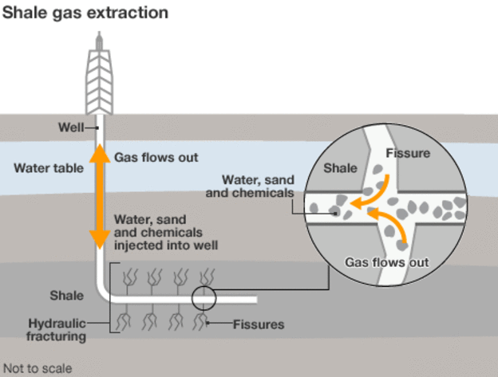
92. The effects of oil on ecosystems and biodiversity depends on a number of factors:
1. Type of Oil (Crude or Refined),
2. Amount released,
3. Distance of release from shore,
4. Time of year,
5. Weather conditions and water temperature
6.Ocean currents.

Preventing an oil spill can be done in the design of the tanker: double hulls could prevent the oil from spilling in the event of a collision. Only the outer hull would be damaged, leaving the oil containers intact. Clean up of an oil spill can be done using
- portable pumps to transfer as much oil as possible onto another vessel;
- skimmers to remove oil from the surface of the water
- absorbents (straw can also be used to absorb it);
- power washers to spray hot water and detergents to remove the oil from the rocks
- sets of booms to contain the spill area and prevent it from reaching the beach
- Bioremediation using bacteria can also be done to remove oil from the ecosystem.
- Chemical dispersants break the oil slick into smaller droplets. So they sink just beneath the surface but not all the way to the bottom. The oil emulsifies in the water and can be ingested by fish, entering the food chain. Dispersants are suspected carcinogens

Most of the pollution from oil comes from minor spills (leaks or runoff from streets) rather than from major oil spills! Oil from non-point sources such as roadways and residential streets get into waterways and eventually the ocean. Groundwater supplies can become contaminated from leaks in underground storage tanks.

93. Air pollution from fossil fuels:
- Burning fossil fuels (all of them, including natural gas) emits heavy metals such as mercury and lead. Heavy metals are neurotoxins leading to brain or nerve damage in humans, especially learning disabilities in children. Mercury and lead are examples. Cadmium is linked to heart disease
- Oxides of sulfur and nitrogen are common air pollutants. As gasses, they can cause asthma, bronchitis or emphysema. They combine with water vapor and oxygen to form secondary pollutants- sulfuric acid and nitric acid, then enter soils and aquatic ecosystems. Acid rains leach heavy metals from soils. Metals such as aluminum can cause excess mucus to build up in gills of fish, suffocating them. Acid rain also damages leaves, lower productivity of land plants and cause plants to become more susceptible to disease and insect attack
- Particulates like soot and ash damage lung tissue leading to asthma, bronchitis and emphysema. Increase likelihood of heart disease
- Photochemical smog forms when nitrous oxide (NOx) and volatile organic compounds (VOC) in the air react together in sunlight to form small particles which produce brown or gray haze. Smog also leads to asthma and other respiratory illnesses. Ground level ozone is part of smog, formed when NOx from mobile combustion is split by sunlight and releases an oxygen atom, which then combines with oxygen gas to form O₃ (ozone)

- Carbon dioxide gas emissions that trap infrared radiation (heat) contributing to global warming. One effect of global warming is the thermal expansion of ocean water causing sea levels to rise and glaciers to melt, soils to dry out and insect breeding grounds to be found farther north of the usual areas

The US CLEAN AIR ACT of 1990 was implemented to reduce sulfur dioxide emissions that caused acid rain, but also Pb, ozone, NO_{x}, CO and PM (particulate matter) as well. These are known as CRITERIA POLLUTANTS. Note that carbon dioxide is NOT a criteria pollutant!

94. Plate tectonics: divergent boundaries, where plates move APART, form mid-ocean ridges which are basically underwater volcanoes. However, these volcanoes are formed from the spreading of the plates apart (seafloor spreading). Iceland is formed from plate divergence in the middle of the Atlantic Ocean. This makes geothermal energy and H fuel (from water) very important energy sources. No fossil fuels in Iceland unless imported.
Convergent boundaries form when plates COLLIDE. Mountains are always formed. These become volcanoes if one plate is forced under another, melting into magma. Most of these volcanoes are along the Pacific Ring of Fire (around the edges of the Pacific Ocean). Earthquakes at these boundaries can cause tsunamis.
Hot spots form in the middle of plates. No boundaries involved. Hawaii and Yellowstone are hot spot volcanoes
Transform boundaries form when plates SLIDE PAST EACH OTHER. Faults are created. The San Andreas fault system in California is the worlds largest. Earthquakes happen along faults.
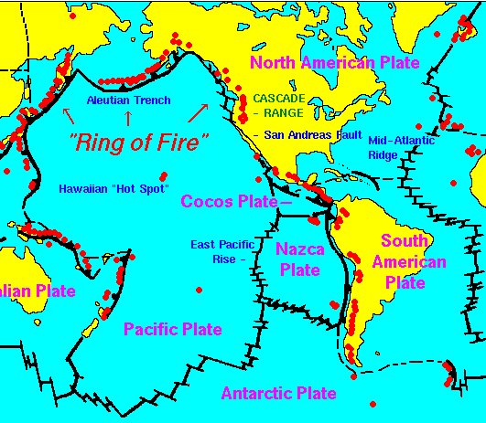

95. Earth’s Atmosphere consists of 78% nitrogen, 21% oxygen and 1% argon. Everything else is present in trace amounts. Human activity is increasing the amount of carbon dioxide (CO₂), methane (CH₄), nitrous oxide (N₂O), ozone (O₃) and chlorofluorocarbons (CFCs) all Greenhouse gases.

96. Earth’s atmosphere consists of 4 layers: Troposhere (where weather happens)
Stratosphere (containing good ozone)
Mesosphere (meteors burn up)
Thermosphere (traps gamma rays)

97. Greenhouse gases in the troposphere trap outgoing infrared radiation, re-emitting them back towards the planet. The results in global warming. Water vapor, bad (tropospheric) ozone, carbon dioxide, methane, nitrous oxide and CFCs are greenhouse gases. Methane has 25 times more greenhouse warming potential (GWP) than carbon dioxide but because there is so much more CO₂, it is seen as the main GHG contributing to global warming.

- Carbon dioxide comes from burning of fossil fuels and from deforestation (since removing plants prevents photosynthesis which removes CO₂ from the air) Carbon dioxide levels can fluctuate with season- less in the summer during peak photosynthesis and more in winter when trees lose their leaves
- Methane concentration increases because of manure from concentrated animal feedlots (CAFO), digging for oil and coal, organic decomposition in landfills, flooding of vegetation in reservoirs or in flooding rice fields during cultivation

  - LEARN THE CARBON CYCLE WELL!
    - PHOTOSYNTHESIS: removes carbon dioxide from the air for use by plants in making sugars (carbohydrates) and oxygen
    - RESPIRATION: all living things use oxygen to convert the energy in food to chemical energy of ATP, releasing carbon dioxide to the air
    - DECOMPOSITION: bacteria and fungi break down the bodies of dead organisms, using oxygen to reduce complex molecules to simpler ones such as carbon dioxide
    - COMBUSTION: burning of fossil fuels release carbon dioxide to the air. Fossil fuels are long term storage of carbon since they take thousands of years to form. Combustion returns the carbon to the air
    - SEDIMENTATION: sedimentary rocks contain carbon (such as limestone- CaCO₃) for thousands of years. Chemical weathering releases the carbon to the air.

- Nitrous oxide emissions and tropospheric ozone comes from burning fossil fuels. Nitrous oxide also comes from the increased use of inorganic fertilizer (increased denitrification)
  - LEARN THE NITROGEN CYCLE WELL! You must know the chemical transformations for various stages of the nitrogen cycle. Use the acronym FixNAAD and ANPAAN to match up the process and the product you get in each stage
    - FIX: fixation-bacteria convert nitrogen gas into AMMONIUM or nitrate ions that plants can assimilate. Lightning can also fix nitrogen abiotically
    - N: NITRIFICATION: bacteria convert ammonium into NITRATE ions.
    - A: ASSIMILATION: plants take in nitrates and ammonium ions to use for building PROTEINS, chlorophyll and DNA
    - A: AMMONIFICATION: bacteria convert waste and dead organisms into AMMONIA
    - D: DENITRIFICATION: bacteria convert nitrate ions (NO₃⁻) into nitrogen gas which returns to the atmosphere

98. Reducing greenhouse gas emissions:
- Carbon dioxide levels can be lowered by using renewable energy sources such as wind, solar, hydropower and nuclear (not biomass since this still gives off carbon dioxide though some regard this as carbon neutral because the plant took in carbon dioxide during photosynthesis before it became a fuel; natural gas also gives off CO₂ but less than other fossil fuels).
- Personal choices such as reducing your carbon footprint by walking, car pooling or using mass transit, using less electricity by increasing the energy efficiency of appliances and redesigning buildings all count as well.
- Methane levels can be reduced by capturing and using it for heating or electricity. Waste lagoons and landfills can be covered to trap the methane, which can then be burned to create the steam to turn the turbine to generate electricity.
- Nitrous oxide can be cleaned from car exhaust by using a catalytic converter. Switching to electric or hydrogen fuel cell cars also works
- KYOTO PROTOCOL an international agreement asks countries to commit to reducing emissions of carbon dioxide to pre1990 levels.
- Cap and trade emissions programs to lower overall carbon dioxide levels in the troposphere.
- Carbon capture and sequestration projects to inject carbon dioxide underground in reservoirs from which oil was extracted

99. CFCs are greenhouse gases that can remain in the atmosphere for over a hundred years. They are the strongest greenhouse gases (but not the most plentiful) because they are persistent. They are also the reason for the ozone depletion (ozone hole) over Antarctica. CFCs break down ozone by the following steps:
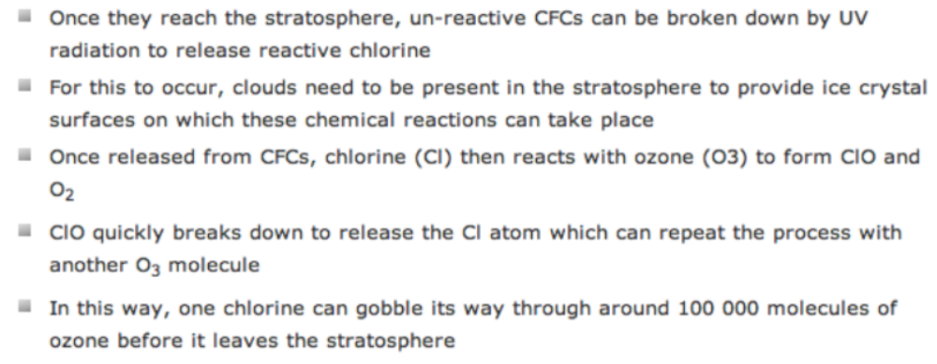
The key factor is the presence of polar stratospheric clouds. This is the reason the hole is over the Antarctic rather than any other continent.

100. The MONTREAL PROTOCOL is the most successful international treaty. Its purpose is to reduce the use of CFCs and protect the ozone layer in the stratosphere

101. OZONE is both good and bad (advantageous and disadvantageous). In the stratosphere, ozone protects us from UV-B rays which cause skin cancers, eye damage (cataracts) and lower photosynthetic productivity. In the troposphere, ozone is formed as a pollutant in photochemical smog, causing respiratory illnesses. Photochemical smog is formed when NOx from mobile combustion is split by sunlight and releases an oxygen atom, which then combines with oxygen gas to form O₃ (ozone)

102. comparing energy sources-see chart below
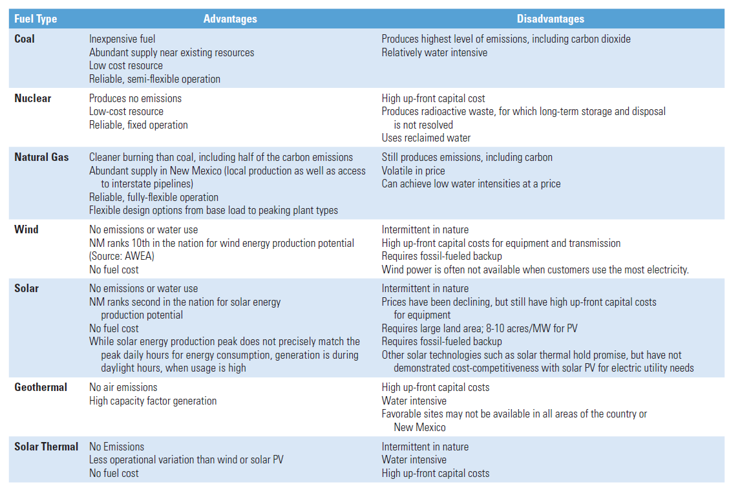

103. Hydrogen fuel cells never need recharging since the H fuel is not part of the cell. The H fuel is supplied by the tanks that are filled at the “gas” station. The H gas is split into H⁺ ions and electrons by the catalyst at the anode side of the cell. The electrons flow through the circuit and are picked up by oxygen and H⁺ ions at the cathode side of the cell, forming water as the only waste product. Because hydrogen does not exist as a gas on Earth, it must be created before it can be stored in the tank under the car (or bus). Solar is one way to create the hydrogen from water at the ‘station’. Currently, the infrastructure (stations) is not in place to make hydrogen fuel cells immediately viable.

104. “Light Bulbs”: incandescent bulbs are only 5-10% efficient. Most of the energy is wasted as heat. Fluorescent and LED bulbs are better. This is one way to conserve energy. Other ways include unplugging appliances when not in use, buying energy efficient appliances, using solar energy and so on

105. Solar Energy: Pros and Cons (see powerpoint notes) however, discussing the lack of emissions compared to coal is a good start. Learn the difference between using PV cells and power towers (solar collectors).

106. Pros and Cons of using biofuel energy sources: (ethanol and biodiesel)
- A NOTE ABOUT BIOFUELS:
Biofuels can help mitigate climate change because they are made from plants, such as sugarcane and corn that absorbed carbon dioxide during photosynthesis. When we burn fossil fuels we add carbon dioxide to the atmosphere from long sequestered sources, but burning biofuels releases carbon dioxide that was taken out of the atmosphere by plants and algae only a few days, weeks or years earlier during photosynthesis. So this creates a rapid carbon cycle, helping to prevent FURTHER build up of carbon dioxide. This is why some people think they are carbon neutral.
HOWEVER, converting plant material to biofuel takes energy! That energy comes from burning fossil fuels. Ethanol made from corn and biodiesel made from canola and soybeans require energy in the distillation phase. The net effect of their use on greenhouse gases is negative rather than positive! Plus, a lot of fertilizer and pesticide was used to grow them. Excess nitrates become N₂O during denitrification, adding to the build up of greenhouse gases and climate change OR run off during irrigation and leads to cultural eutrophication of surface water. Pesticides in runoff cause feminization of fish.

107. Be able to sketch and describe how each of the following generates electricity:
  - Wind turbine
  - Hydroelectric plant
  - Coal fired power plant
  - Power tower (solar thermal collector)
  - PV cell
  - H fuel cell
  - Nuclear power plant (pay attention to the 3 separate loops of water and parts of the reactor!)

108. While energy conservation has clearly grown in some sectors, TWO specific reasons why we are not doing more to reduce fossil fuel use are the low price and high efficiency of the fuel

109. Radon as a naturally occurring radioisotope from granite bedrocks. A hazard in homes with basements built over such bedrocks, so counts as indoor air pollution. Only good ventilation can mitigate this. Radon has been shown to cause lung cancer.

110.Symptoms of radiation sickness / effects of exposure to radiation include vomiting, fatigue, spontaneous abortions or male sterility and cancers.

111. Be able to explain the difference between Low level and high level nuclear waste (what is it and how to handle it…) Low level Nuclear waste sites must be
- geologically stable, very little earthquake or volcanic activity
- No flowing groundwater or surface water to contaminate
- Have a stable climate, free from water percolating in/through; no soil erosion; no excessive heat

112. Case Studies: Chernobyl, Three Mile Island, Fukushima. Know the causes and consequences of these accidents (see powerpoint)

113. Yucca Mountain, Nevada: the proposed site for permanent storage of high level nuclear waste, 70 miles northwest of Las Vegas. Critics are concerned about the safety of transporting high level radioactive waste to the site and the proximity of the site to a earthquake faults.

114. BE ABLE TO CALCULATE HALF LIFE AND THE AMOUNT REMAINING FOR RADIOISOTOPES!

115. Pros and Cons of nuclear power:
- Does not increase potential global warming since it does not release carbon dioxide
- Does not cause acid rain or air pollution by sulfur dioxide or NO_{x}
3. Waste disposal is difficult. High level waste stored in pools on site, waiting for the very long time it takes to decay to safe levels. Waste must be protected from terrorists.
4. Thermal pollution due to the use of water as a coolant
5. Plants are expensive to build and even more expensive to decommission. Decommissioning plants are very expensive since the owners must take steps to reduce the level of radiation so that the land can be used for other things

116. DESIGNING AN EXPERIMENT
- HYPOTHESIS MUST ALWAYS be written as an IF/THEN statement that includes both the IV and the DV (no other style will be accepted)
- The INDEPENDENT VARIABLE (IV) is the part of the experiment the scientist manipulates od deliberately changes. There can be only ONE IV in an experiment
- The DEPENDENT VARIABLE (DV) is the result or response that is observed in the experiment. There can be many of these but you should design your experiment to look for ONE OR TWO SPECIFIC RESULTS.
- ALWAYS ADD A CONTROL GROUP. This is an experiment or group that you did nothing to. It is for comparison.
- ALWAYS HAVE REPEATED TRIALS. Add at least 3 and say you will take the average of those three.
- CONCLUSIONS are made from the results of the experiment only. You will be asked to predict these and suggest the significance of your results.

117. FACTS TO CRAM because they WILL be on the test
- Resource Conservation and Recovery Act (RCRA): controls hazardous waste with cradle-to-grave system requirements for the manufacture, transport, storage, use and disposal of hazardous chemicals. Also governs the monitoring of LANDFILLS
- LD 50 is the amount of a toxin that will kill 50% of the population. The lower the LD50, the greater the toxicity of the substance (meaning a smaller dose will be fatal)
- THRESHOLD LEVEL FOR TOXINS- level below which there is no effect and above it there is an effect (when the graph just starts to rise)
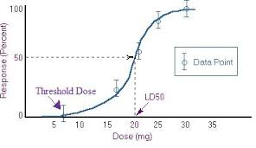
- EXTERNALIZED COST OR EXTERNALITY is the negative effect (like pollution) of an economic transaction that is not reflected in the actual cost of the product or service. For example, a cotton shirt does not include the cost of the pesticide runoff from the sprays used on the cotton fields.
- CERCLA = Superfund Act imposes a tax to be used to clean up hazardous waste sites.
- COGENERATION: using the waste heat from a power plant to warm buildings such as prisons or greenhouses (waste as a resource)
- SYNERGISM= where two or more harmless substances combine to have a greater toxic effect than if they were alone
- FOOD RELATED DISEASES;
  - Marasmus= undernutrition, caused by lack of calories; extreme emaciation and muscle loss
  - KWASHIORKOR= malnutrition, caused by lack of protein in diet; stunted growth and slow mental development in children
  - ANEMIA= lack of iron (micronutrient) in the diet; can be fatal to women in childbirth; causes loss of energy and inability to work
  - VITAMIN A DEFICIENCY= lack of vitamin A micronutrient; causes blindness and poor resistance to infections in children
- TEMPERATURE (THERMAL) INVERSION: occurs when a relatively cool layer of air covers a layer of warmer air below. The warmer inversion layer traps air pollutants. Los Angeles has the worst temperature inversion in the US.
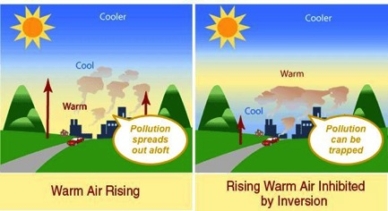
- EL NINO (ENSO CYCLE) occurs when the eastern Pacific Ocean (near Peru) warms up. This is due to weak winds and no upwelling of cold water from the ocean floor. Productivity lowers, heavy rainfall occurs and diseases such as malaria increase.
- RAINSHADOW EFFECT: creates deserts on the leeward side of hill
  - 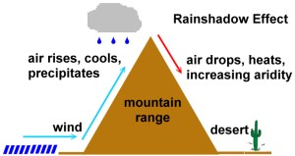

THESE MAY BE ON THE TEST THIS YEAR-
- OVERFISHING: result of unsustainable harvesting of fish such as cod, tuna, salmon at rates faster than they can reproduce. This is an example of a tragedy of the commons. Fishing technology such as longlining, purse seining and bottom trawling remove large numbers of species. Effects and consequences include accidental by catch of non-target fish, turtles and birds. Mitigation= ban on some fish; establishing quotas; fish farming though this produces large amounts of fish waste and contributes to high BOD levels and hypoxia in the ocean. Relevant laws: marine sanctuaries act that restrict fishing in certain areas; CITES treaty that regulates fishing in international waters
- PALM OIL INDUSTRY: large areas of tropical rainforests in Asia have been cut down to make room for vast monoculture oil palm plantations. This destroys habitats for many endangered species of rhinos, orangutans and tigers and lowering biodiversity. Also deforestation increases the level of carbon dioxide in the air, leading to climate change; increases soil erosion as well since there are no roots to anchor soil or leaves to shelter soil from wind; increases runoff and flooding. Agriculture implies increased use of fertilizers and pesticides leading to cultural eutrophication, bioaccumulation of pesticides in local food chains and possible loss of beneficial insects through contact with pesticide-laden plants and so on. Palm oil is used in cosmetics and for many snack foods
- FOOD WASTE: contributes to climate change as food waste (peels, uneaten restaurant dishes, spoiled produce from markets…) is thrown away in landfills, where it decomposes and emits methane, a greenhouse gas that leads to climate change. Also growing food (agriculture) takes large quantities of water, fertilizer and arable land. Processing food requires energy to transport and refrigerate it, thus adding to the environmental impact of food waste. Mitigation can include composting and donating food to local shelters and serving smaller portions in restaurants, capturing and using the methane to produce electricity
- LEAD (OR MERCURY) IN WATER: heavy metals like lead and mercury are neurotoxins and both bio-magnify up the food chain. Both may be emitted from the combustion of coal burned for producing electricity. They may lead to learning disabilities in young children. Pregnant women should avoid them. Mercury is eaten in top predator fish like tuna. Lead is often in the pipes of old homes (like flint, Michigan) and is leached out when the water becomes corrosive. Mitigation for lead: adding a corrosion inhibitor such as orthophosphate to the water; attaching water filters to the taps in your home; use bottled water. Mitigation for mercury: eat lower on the food chain; burn less coal by relying on renewable energy sources such as solar or wind for generating electricity
  - NOTE ABOUT FLINT, MICHIGAN: the water from the Flint River was corrosive due to high levels of de-icing salt in the water. This, plus the extra chlorine added to kill bacteria in the water, created high levels of chloride ions in the water.
- CLIMATE CHANGE: anthropogenic caused increase in GHG like carbon dioxide, nitrous oxide and methane results in increased air temperatures. GHG resonate at the frequency of infrared radiation (heat) coming from the surface of the earth. Effects include declining ice sheets in the artic and Antarctic; increase in sea levels due to melting land ice and thermal expansion of sea water; thawing permafrost (frozen soil) which further releases methane into the air, triggering a positive feedback loop of even more thawing and release of methane; increase in insect borne diseases such as malaria; ocean acidification from more carbon dioxide; more short term droughts and intense storms…burning fossil fuels, fertilizer intensive agriculture, deforestation for creating farms and intensive animal agriculture are the main ways GHG are released into the atmosphere
- BEES: honeybee populations are declining in part due to use of pesticides and loss of wildflowers. Bees are important pollinators and are used in agriculture to pollinate crops such as almonds and citrus. Mitigation: using IPM to control pests and to preserve ecosystems with wildflowers so that bees can find food when crops are not in flower.
- WIND ENERGY: UNEVEN HEATING between land and water (or snow covered mountain tops and desert valley floors) create uneven pressures in the air above the surface. Air flows from HIGH TO LOW pressure areas as wind. Wind turbines bludgeon birds and bats, lowering their populations. Some people consider them unsightly as visual pollution. Plus, they need large amounts of land. However, the energy is renewable and will cause no water or air pollution (see fossil fuels for specific names of air and water pollutants). And you can use the land under a wind turbine for grazing animals.

118. APES MATH:
- good numbers to know-
  - US population is 310 million people (3.1 x 10⁸)
  - World population 7 Billion (7 x 10⁹)
- Know simple conversion factors such as the number of watts in a kilowatt (1000) and the number of kilowatts in a megawatt (1000). Know that 1m³ = (100cm)3 or 100cm x 100cm x100cm = 1,000,000cm³
- Energy is measured in kWh for electricity or BTUs for heat energy.
  - Multiply the kW by the time in hours to get kWh
For example, if your home uses twenty 100 watt bulbs for four hours per day, how many kWh of electricity are needed to power the bulbs for one year?

20 bulbs x 100 watts/bulb x 4 hours/day x 365 days/year = 2920000 watt hours/year

Then to convert to kilowatt hours you divide by 1000 since there are 1000 watts per kilowatt. The answer is 2920 kWh/year

HOW TO DRAW A GRAPH:
- range of data ÷ number of grid lines, then ROUND UP to find a scale for each axis
- the independent variable (manipulated by experimenter) goes on the x axis and is LABELED with units
- the dependent variable is always on the y axis, also LABELED WITH UNITS
- draw a best fit line unless told otherwise
- any information interpolated from the graph must be marked on the graph as well as in the answer document
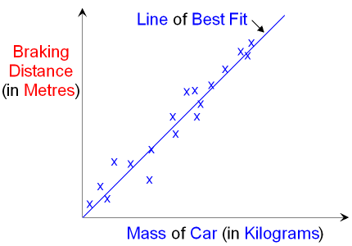

  - 10,000 BTUs = 1kWh. A BTU is the amount of heat required to raise the temperature of 1 lb of water by 1 degree Fahrenheit. You write it like this:
BTU
Lb°F or upside down if needed

